# Greedy Method

# Coin Problem

## Minimum coin exchange problem (Dynamic Programming)

## Number of ways to get the total

# Knap Sack Problem

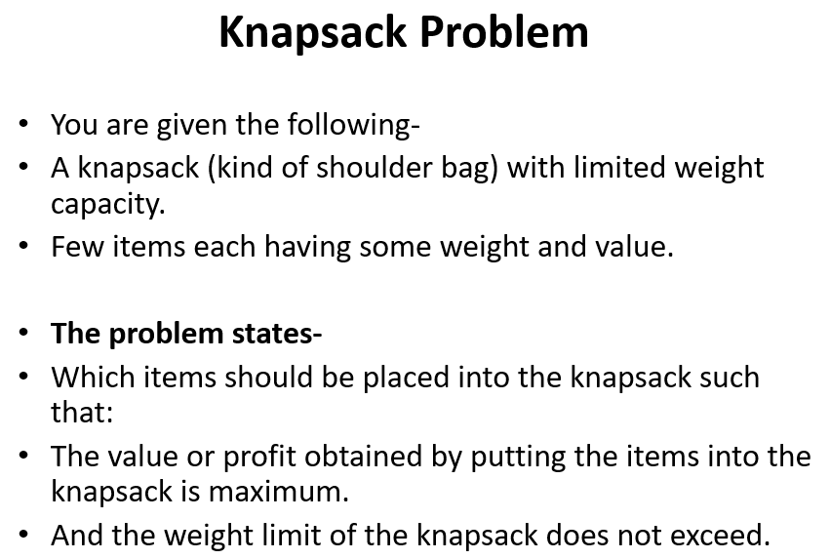

## 0/1 Knapsack Problem (Dynamic Programming)

## Fractional Knapsack Problem (Greedy method)

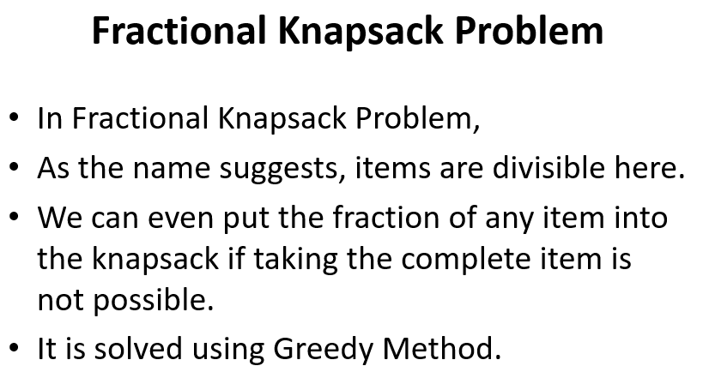

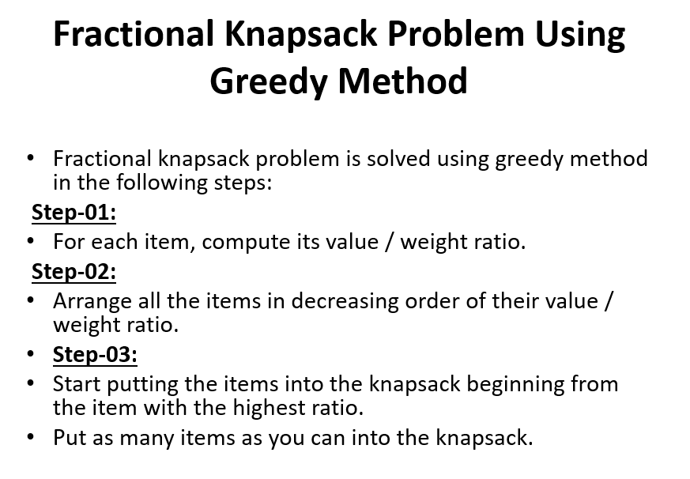

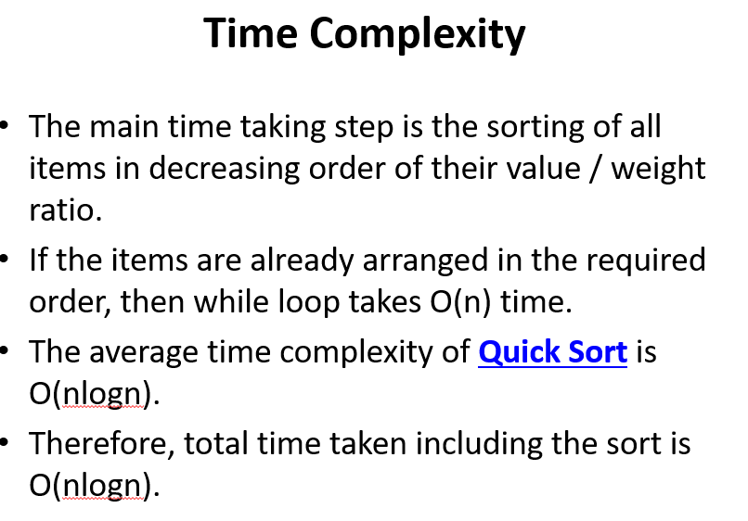

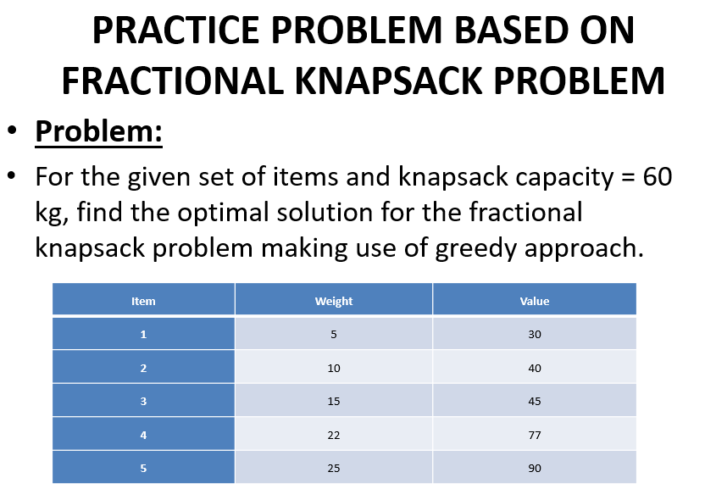

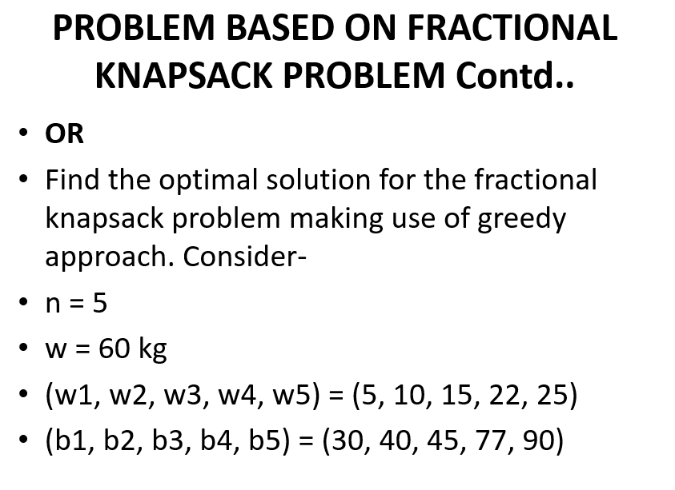

# Spanning Tree

## Minimum Cost Spanning Tree

## Prim’s algorithm to find Minimum Cost Spanning Tree (Greedy)

## Kruskal’s algorithm to find Minimum Cost Spanning Tree (Greedy)

## 

